9 SOUTH BRYN MAWR AVENUE, BRYN MAWR, PA 19010 I PHONE: (610) 525-0706

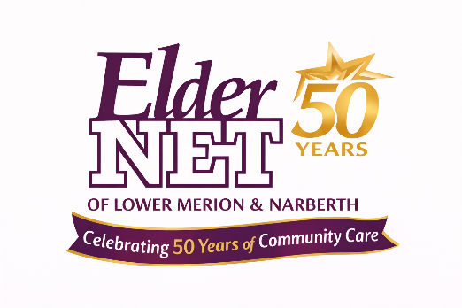
ElderNet 50th Anniversary Celebration
Sponsorship Commitment Form

Event: ElderNet 50th Anniversary Celebration
Date & Time: Saturday, April 25, 2026 | 10:00 AM – 2:00 PM
Location: Bryn Mawr Gazebo, 9 S. Bryn Mawr Ave, Bryn Mawr, PA 19060
Thank you for your interest in supporting ElderNet’s 50th Anniversary Celebration. Please complete the form below to confirm your sponsorship or raffle donation.

Sponsor Information
Business / Organization Name: ______________________________________________________________
Primary Contact Name: ____________________________________________________________________
Title: ___________________________________________________________________________________
Email: ______________________________________ Phone: ___________________________________
Address: ________________________________________________________________________________
City __________________________ State ______ Zip ______________________

Sponsorship Selection
☐ Community Champion – $5,000 (Premier Sponsor)
☐ Circle of Care Sponsor – $2,500
☐ Neighbors in Action Sponsor – $1,000
☐ Friends of ElderNet – $500
Please list business name exactly as it should appear in recognition materials and send logo.

Raffle Basket / In-Kind Donation (Optional)
☐ I would like to donate an item or gift certificate for a raffle basket
Description of Item(s): ____________________________________________
Estimated Value: $_____________

Payment Information
☐ Check enclosed (payable to ElderNet)
☐ Please invoice me
☐ Online payment (link to be provided)

Authorization
I/we commit to the sponsorship level or donation selected above in support of ElderNet’s 50th Anniversary Celebration.
Authorized Signature: ______________________________________________
Printed Name: ____________________________________________ Date: _____________________

Return Completed Form To:
Email: jliebling@eldernet.org
Mail:
Attn: Sponsorship
Eldernet
9 S. Bryn Mawr Avenue
Bryn Mawr, PA 19010
Questions? Contact Jill Liebling at 610-525-0706 x108 or jliebling@eldernet.org

